**Math 252 -- Calculus II -- Lab 1 -- B. Plassmann**

**Names:**________________________________

_________________________________

_________________________________

***Work with someone you haven't worked with before -- mix it up a little!***

**Labs are best if done in your group, during lab time.**

Late labs will be penalized 20%, and will only be accepted up to one week late.

Any group lab turned in by an individual will be penalized 10%.

**Rules:**

Work together:

Everyone works on the same problem at the same time.

Everyone agrees on the solution before you move on.

Remember that you are practicing your mathematical

communication skills!

Turn in one paper per group. Make sure that the paper you turn in is clean, clear, and organized.

**Part 1: Practicing Summation Notation**

Write out each sum, showing every term, then also find the answer.

(example) 

(1) 

(2) 

(3) 

(4) 

Write these in summation form:

(6) = 

(7)  = (8) Fill in the table for

You don't need to write out every term. Just give the answer.

|  |  |
| --- | --- |
| n |  |
| 1 |  |
| 2 |  |
| 3 |  |
| 4 |  |
| 5 |  |
| 6 |  |
| 7 |  |
| 8 |  |
| 9 |  |
| 10 |  |
| .  .  .  n | ? |

(9) Bonus: Can you come up with a formula for this one?

 =

**Part 2: Choose Your Weapon (Stewart, Instructor's Guide, 5e)**

When finding the area under a curve, which point should you use to define the height of each rectangle? Which ones give underestimates or overestimates? Do all the methods approach the same result?

Your group is going to attempt to approximate the area of the region shown on the graphs on the next page. Notice that .

As you have seen, a good way to accomplish this task is to divide the interval up into equal segments along the x-axis, and approximate the area under the curve by vertical rectangles. We pick a point in each interval, , and let the height of each interval be f (). Each person in your group should do only one of the columns on the table below.

Use the enlarged graphs on the next page!

**Person 1**: You’ve landed a lucky load, because when you choose your , you will, whatever the interval, have the labor-saving luxury of always looking to the point on the left of the interval. Approximate the area, using first two subintervals, then three subintervals, and finally six.

**Person 2**: Get ready for some really righteous rectangular rendering. When you choose your , you are required to restrict yourself to the rightmost point on the interval. Approximate the area, first using two subintervals, then three subintervals, and finally six.

**Person 3**: Make merry, for your modeling method is magnificent. When you make your choice of , you must always, whatever the interval, measure to the midpoint of that interval. Approximate the area, first using two subintervals, then three subintervals, and finally six.

|  |  |  |  |
| --- | --- | --- | --- |
|  | Person 1 | Person 2 | Person 3 |
| two-interval approximation |  |  |  |
| three-interval approximation |  |  |  |
| six-interval approximation |  |  |  |

We think that the exact answer is more than _________, is less than _________, and is probably pretty close to _________.

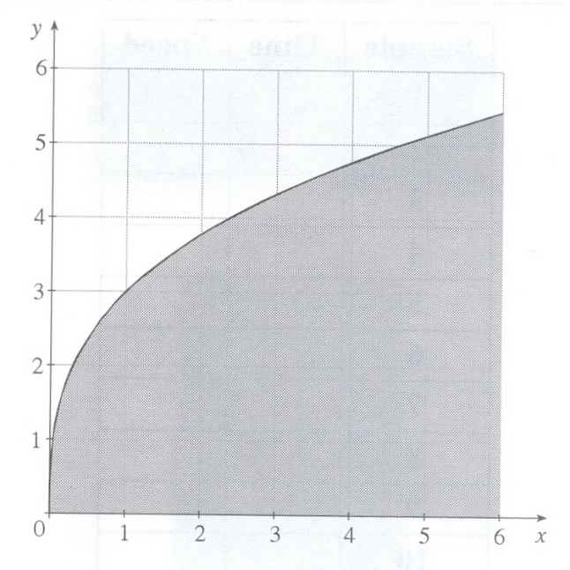

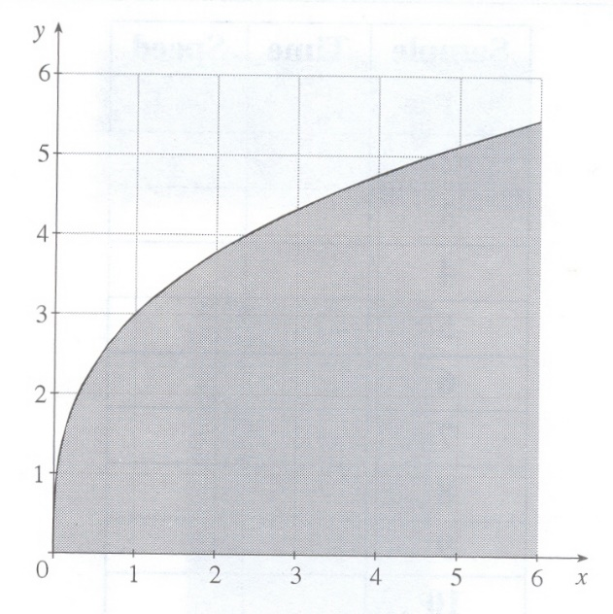

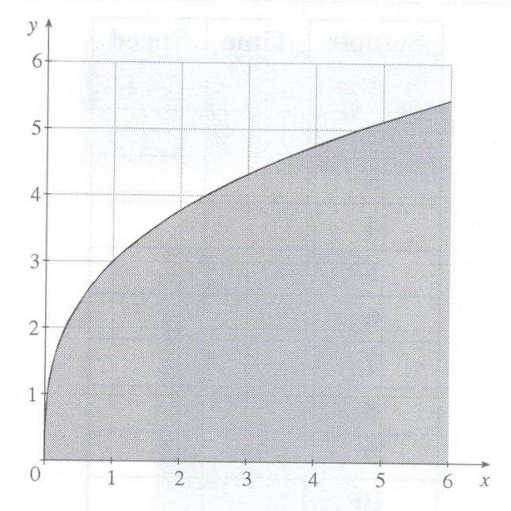

**Part 3: Two Easy Pieces (based on Stewart, Instructor's Guide, 5e)**

**1.** Let f (x) be the piecewise-continuous function graphed below. Estimate the area under the curve from 0 to 4 (i.e. between the curve and the x-axis) by counting squares and pieces of squares on the graph. Show on the graph how you're counting squares.

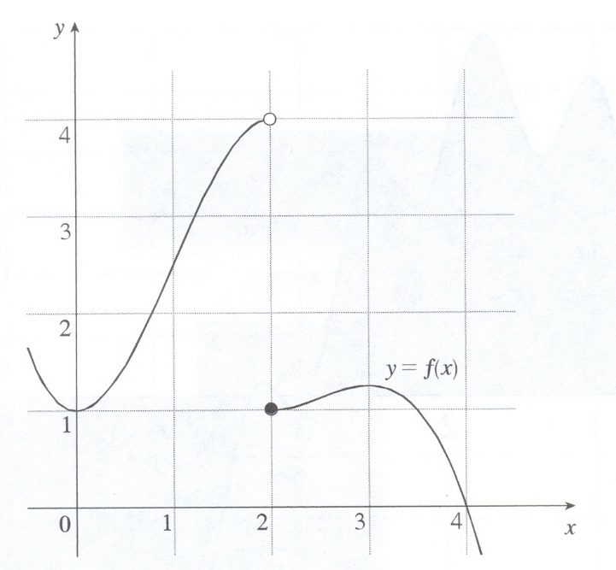

**2.** Compute  and , the left-endpoint and right-endpoint Riemann sum approximations for the area under the curve with two subintervals. Draw and shade the rectangles you use, and approximate the heights as closely as possible.

 

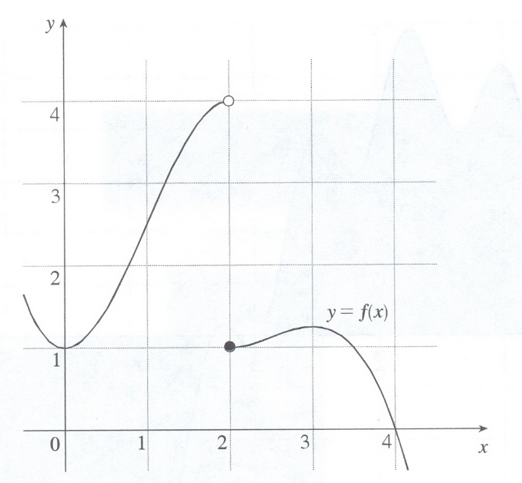 

How do these values compare to the actual value of the integral?

**3.** Now compute  and . Draw and shade the rectangles you use, and approximate the heights as closely as possible.

 

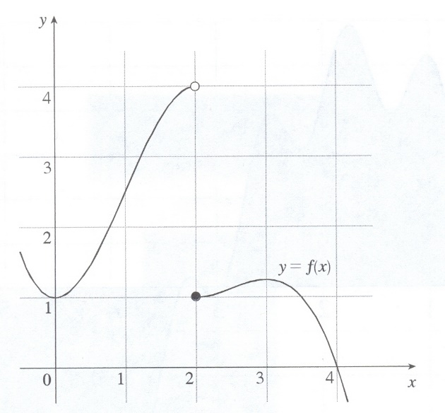 

How do these values compare to the actual value of the integral?

**4.** Now compute  and . Draw and shade the rectangles you use, and approximate the heights as closely as possible.

 

 

**What was the point of this section?** Approximating the area under a curve using rectangles does NOT work well if the function is discontinuous. Notice the contrast between  and  --  was the better approximation, even though it had fewer rectangles, because it skipped the discontinuity.